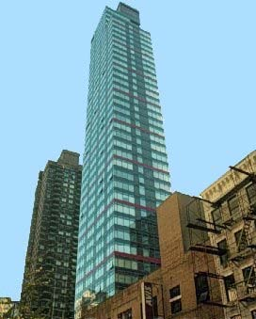

The Mondrian Condominium
250 East 54th Street

